Spelling Dictionary

What is Spelling Dictionary
# Source: AI Source: Provided by: [Data Path: Persons Table -> ID Column: 1, Name_En Column: Motasem Essam] -> From: [Chatgpt (GPT-4-turbo)] on [7/29/2025]
A Spelling Dictionary is a reference tool that provides the correct spellings of words, typically without definitions or with only minimal information. Its primary function is to assist users—especially students, language learners, editors, or people with dyslexia or other language processing differences—in verifying and learning correct orthography.

🔹 Key Features of a Spelling Dictionary
# Source: AI Source: Provided by: [Data Path: Persons Table -> ID Column: 1, Name_En Column: Motasem Essam] -> From: [Chatgpt (GPT-4-turbo)] on [7/29/2025]
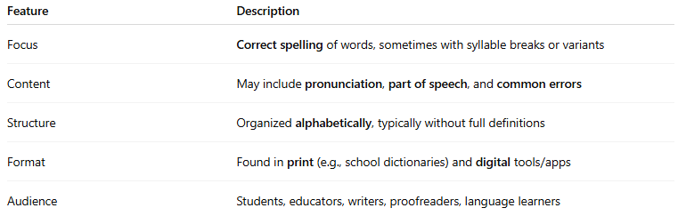
Feature | Description
Focus | Correct spelling of words, sometimes with syllable breaks or variants
Content | May include pronunciation, part of speech, and common errors
Structure | Organized alphabetically, typically without full definitions
Format | Found in print (e.g., school dictionaries) and digital tools/apps
Audience | Students, educators, writers, proofreaders, language learners

🔹 Types of Spelling Dictionaries
# Source: AI Source: Provided by: [Data Path: Persons Table -> ID Column: 1, Name_En Column: Motasem Essam] -> From: [Chatgpt (GPT-4-turbo)] on [7/29/2025]
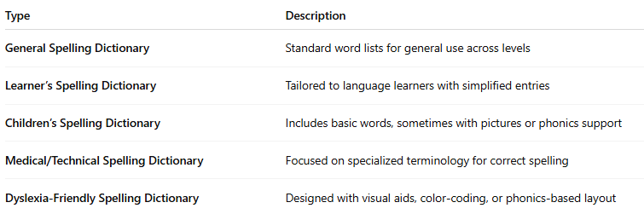
Type | Description
General Spelling Dictionary | Standard word lists for general use across levels
Learner’s Spelling Dictionary | Tailored to language learners with simplified entries
Children’s Spelling Dictionary | Includes basic words, sometimes with pictures or phonics support
Medical/Technical Spelling Dictionary | Focused on specialized terminology for correct spelling
Dyslexia-Friendly Spelling Dictionary | Designed with visual aids, color-coding, or phonics-based layout

🔹 Advantages
# Source: AI Source: Provided by: [Data Path: Persons Table -> ID Column: 1, Name_En Column: Motasem Essam] -> From: [Chatgpt (GPT-4-turbo)] on [7/29/2025]
- Helps users improve writing accuracy
- Supports editing, proofreading, and publishing
- Aids learners with spelling challenges
- Useful in language instruction and exams

🔹 Use Cases
# Source: AI Source: Provided by: [Data Path: Persons Table -> ID Column: 1, Name_En Column: Motasem Essam] -> From: [Chatgpt (GPT-4-turbo)] on [7/29/2025]
- School classrooms and exam prep
- Dyslexia support tools
- Proofreading and editing processes
- Spelling competitions and writing workshops

